W1 Installs
Kalpana Renjarla
CT5130 Intro to SQL for Data Analytcs - CRN195
Huseyin Umut Aksu
New England College
07-18-2026

- Installing PostgreSQL
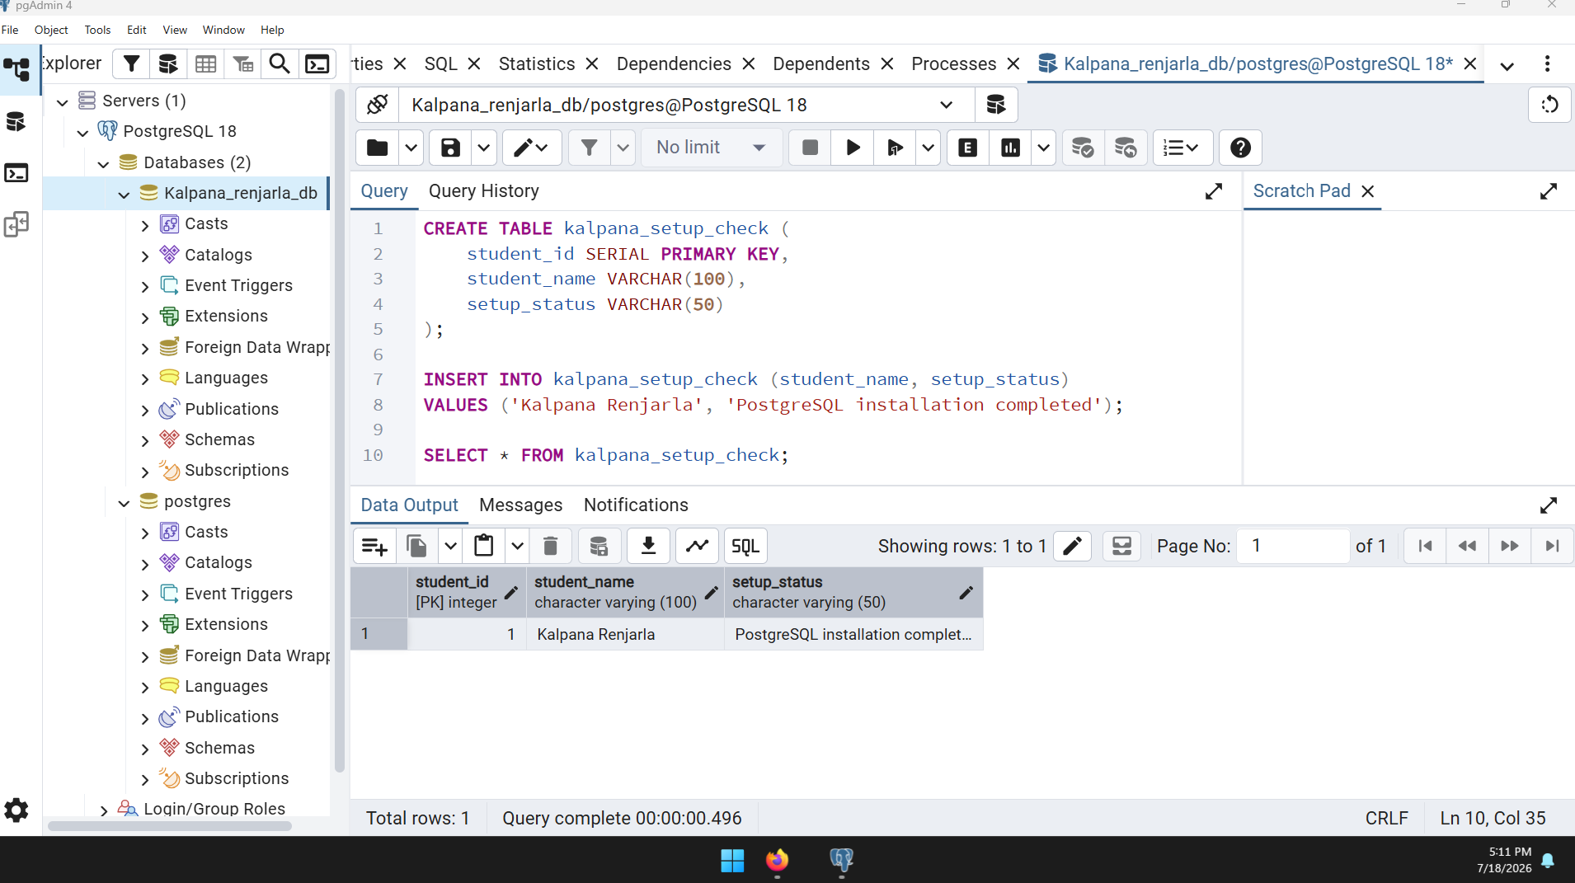
PostgreSQL and pgAdmin installation is complete.
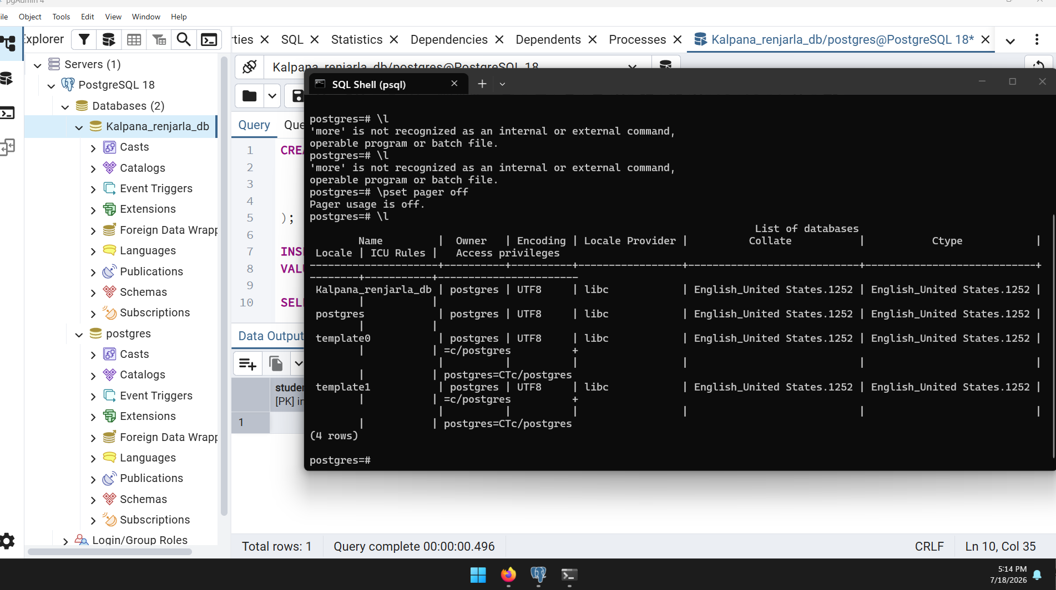
- Installed Python and idle
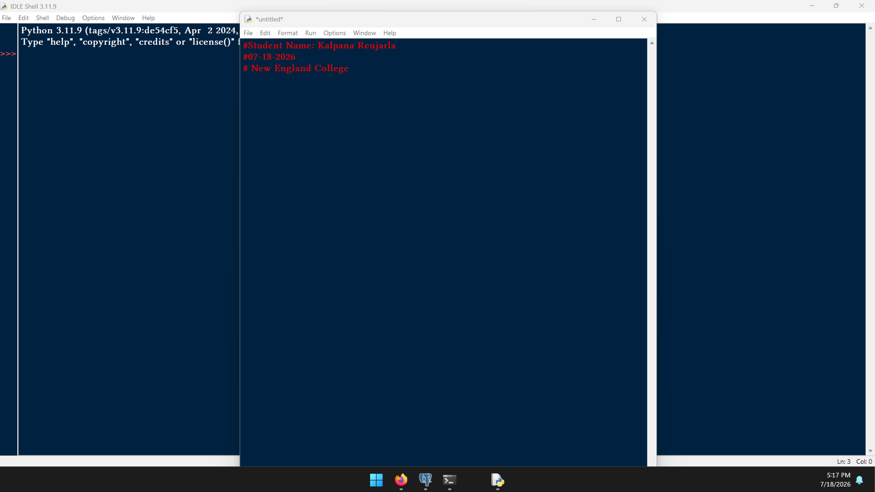
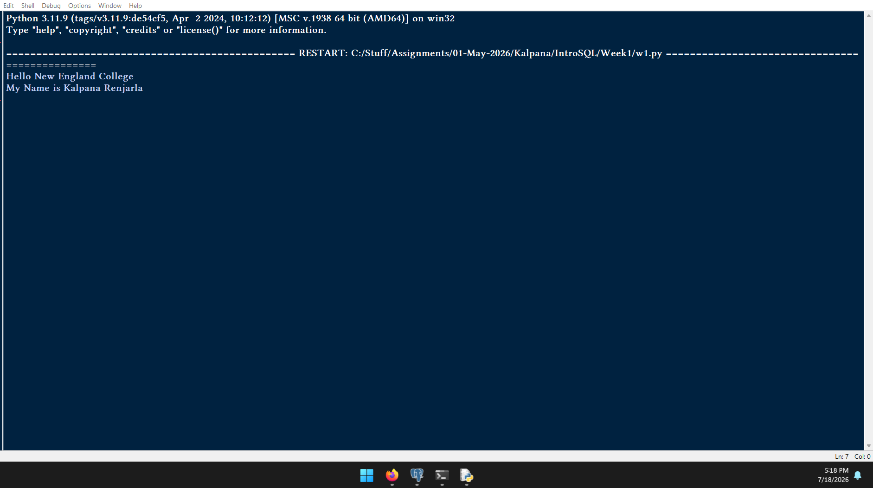
- Created GIT hub account and below is the screenshot for reference
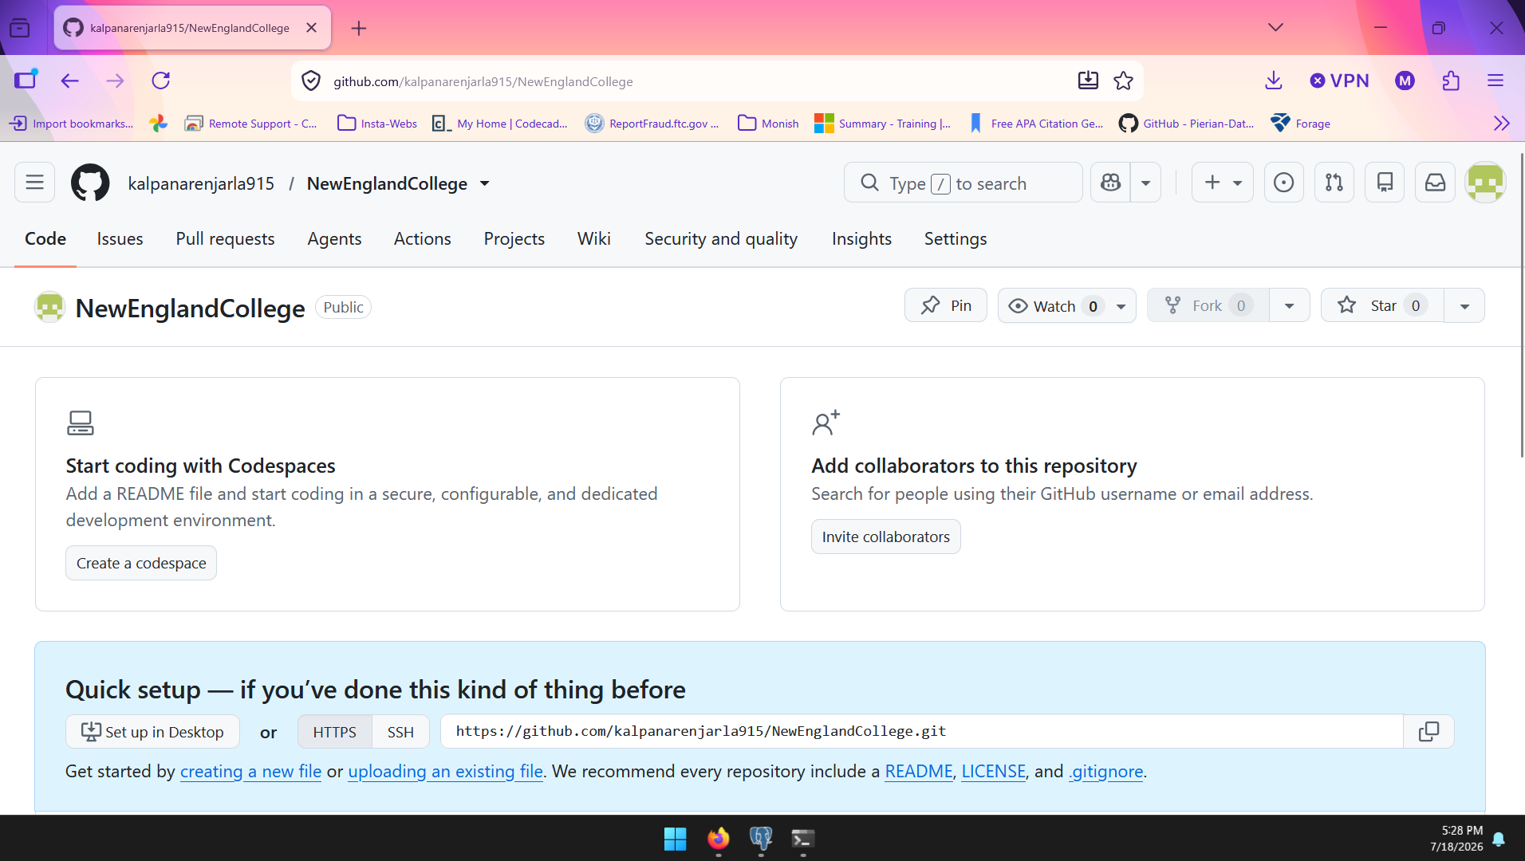
4. – Installed R Studio and below is the screenshot for reference
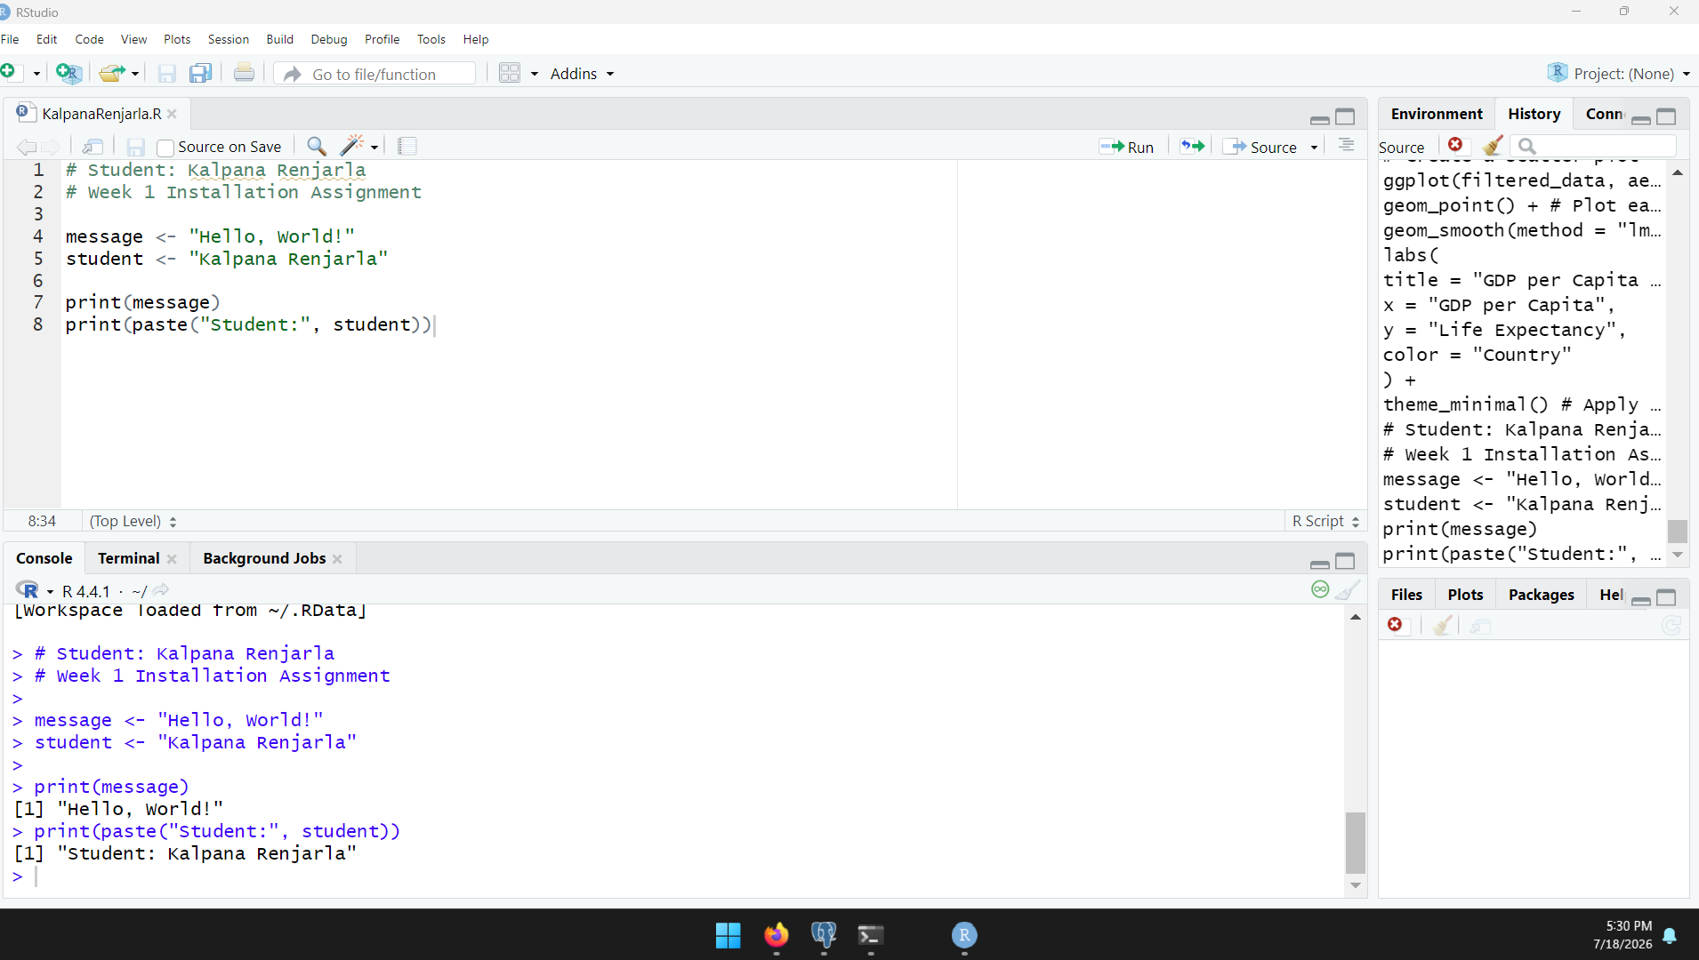

5. Sqlda tables in pgadmin
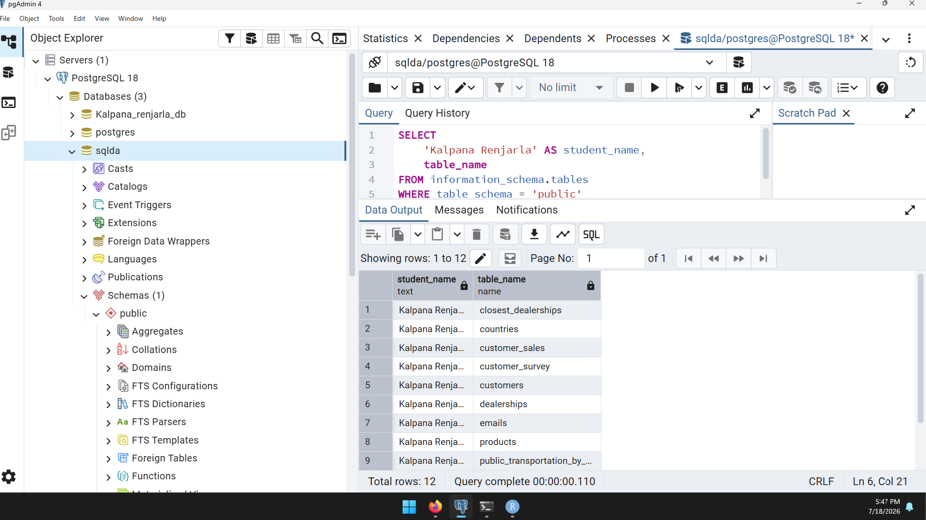
All the software and tools required for this course have been successfully installed and tested. PostgreSQL and the sqlda database, Python IDLE, GitHub, R, and RStudio are functioning properly. The screenshots above confirm the successful completion of the installation process.

